GRC 103 Lab Report: Practical Risk Monitoring with Wazuh

Student Name: Oluwatimilehin Oluwagbemi

Reg. No: 2025/GRC/10712

Date: 25th October, 2025

Lab Objectives:
In this Lab we demonstrate how GRC efforts supports technical controls by monitoring. Wazuh was deployed to achieve the objectives of this Lab, Wazuh is an open-source security platform.
Key learning outcomes:
- Risk treatment was deployed using File Integrity Monitoring (FIM)
- Unauthorized file modifications were monitored in real time
- Alerts and access control effectiveness was analyzed
- Compliance reporting through centralized dashboard
Scenario Summary:
Scenario case used is the modification and deletion of sensitive financial forecast document which tends to a medium-to-high risk.
To attempt this scenario/lab work, I deploy Wazuh agent on my VirtualBox using a bridged adapter, also install Wazuh manager on my Windows Machine.
The following are the screenshots of Wazuh Agent showing the dashboard, compliance report and the modification and deletion of sensitive financial forecast document:
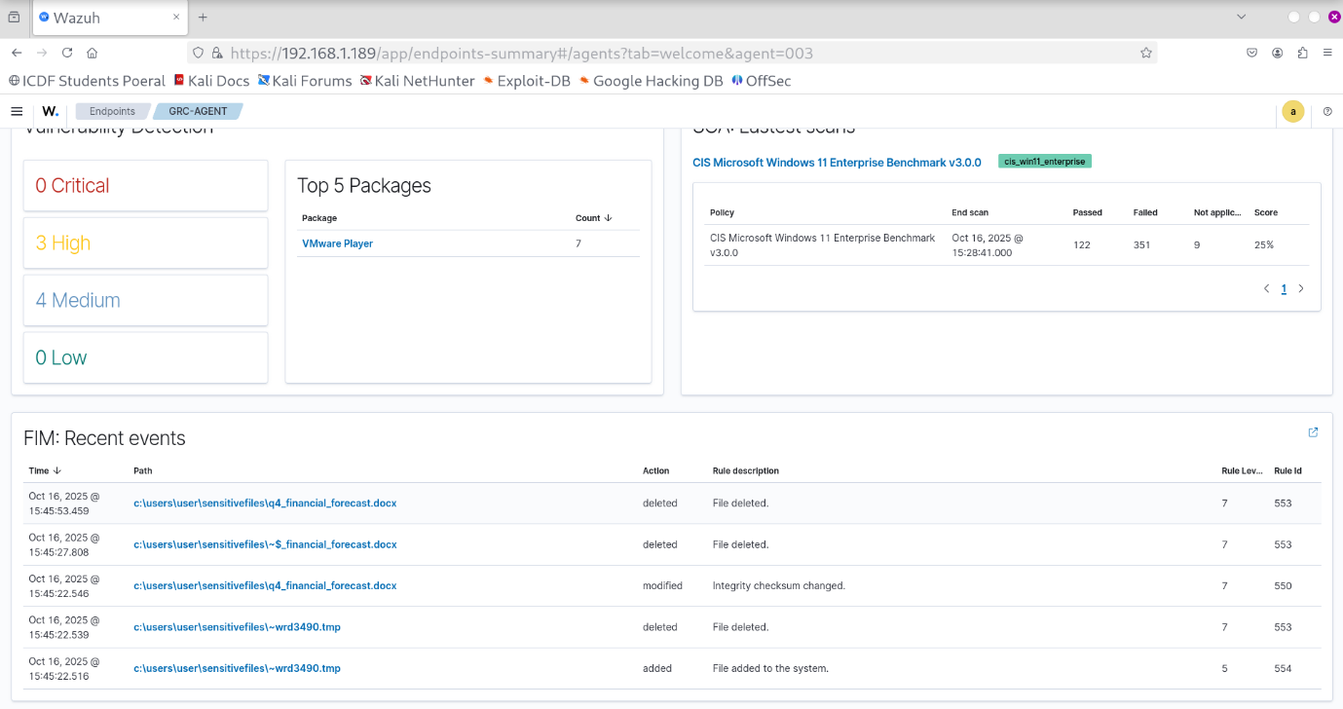
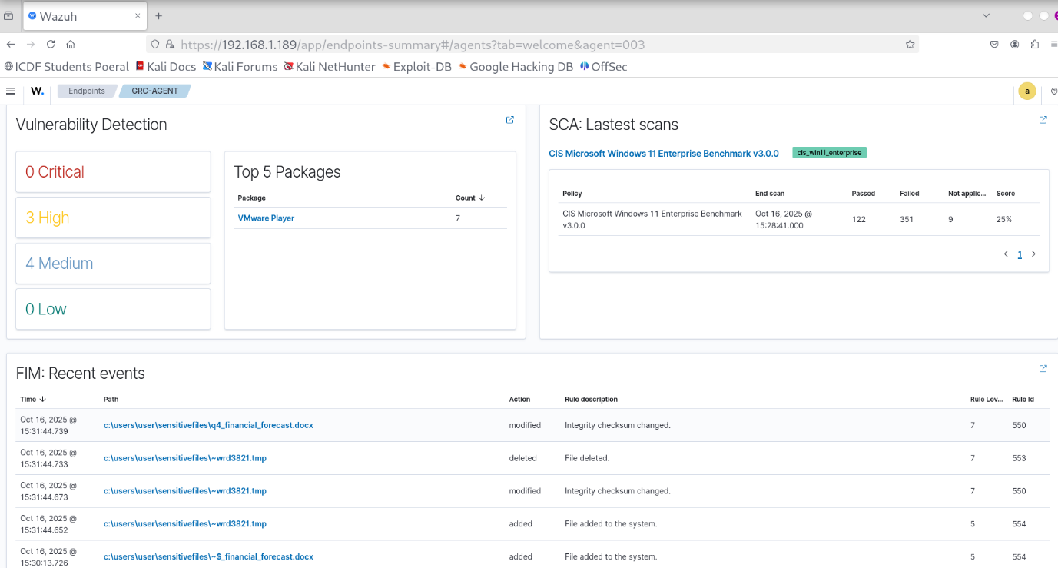
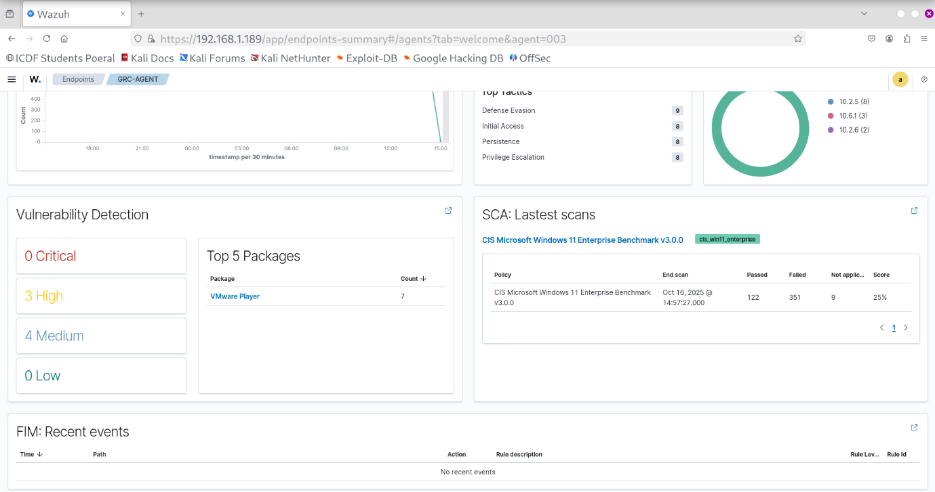
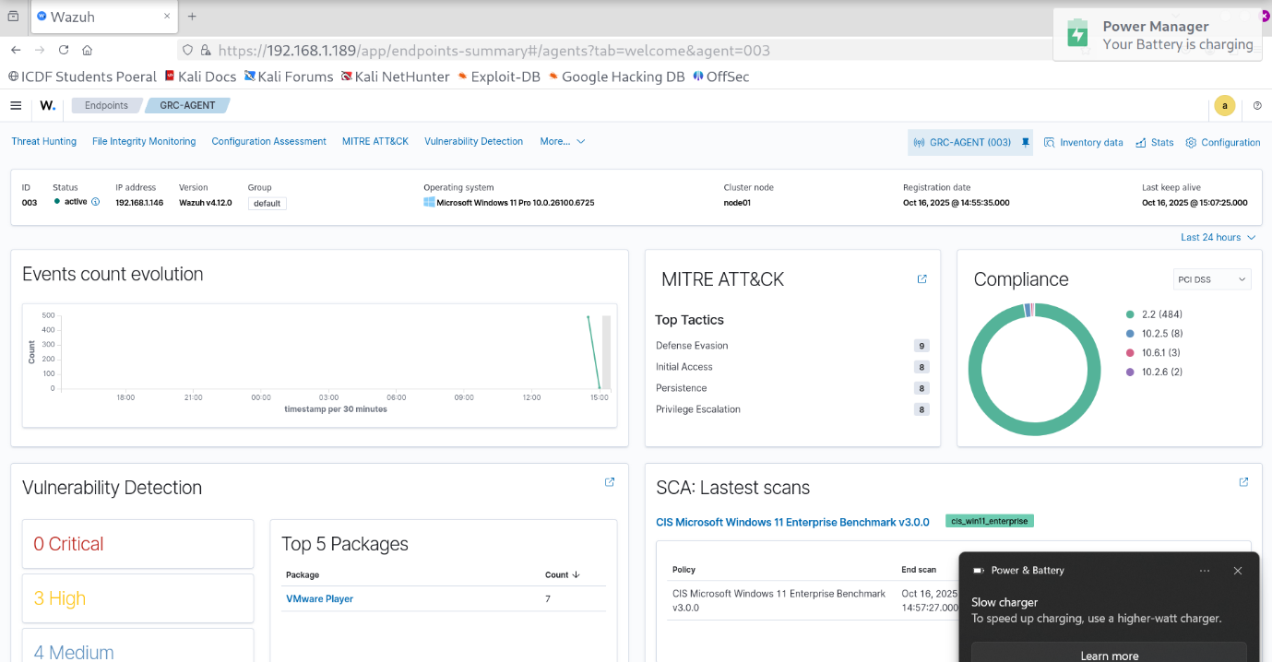

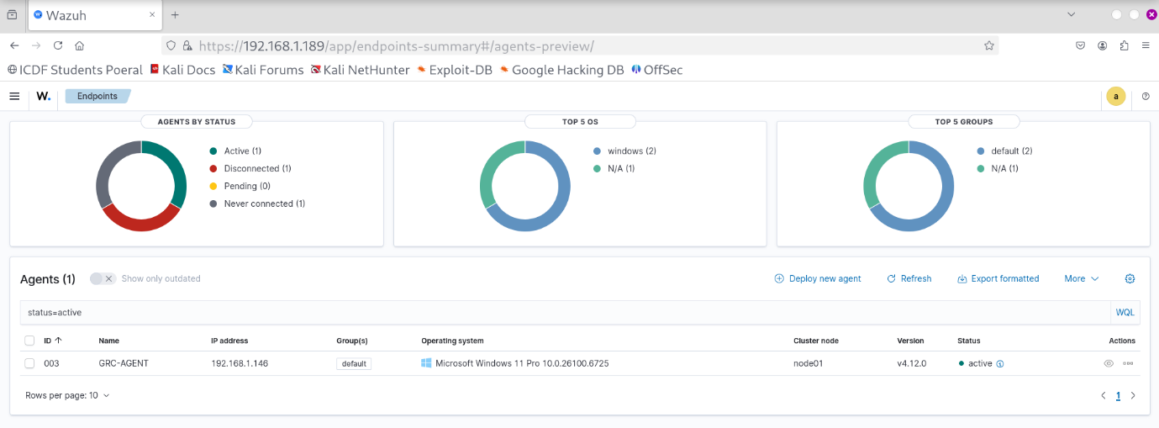

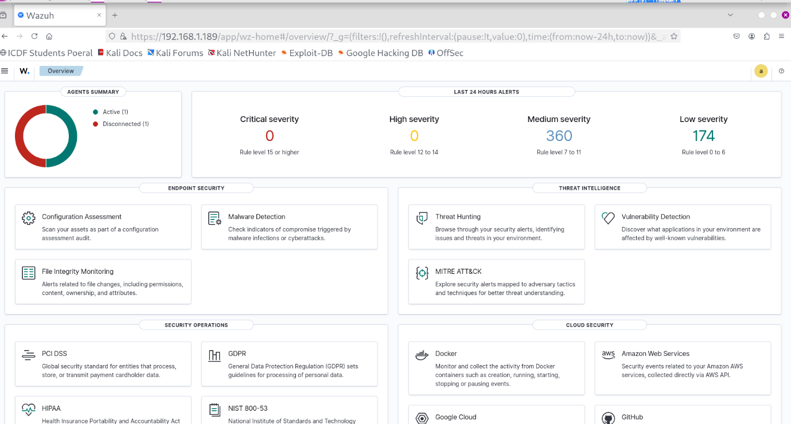
Analysis Question:
- Risk Identification and Analysis: in this scenario the risk is unauthorized. The potential business impact if this risk were realized will be Reputational Damage, the data has been compromised by unauthorized access. The alerts generated helped in quantifying risks through the timestamps generated providing evidence of how the file events took place.
- Control Evaluation and Treatment: complementary preventive control for this risk is access restrictions using NTFS permissions or Active Directory. Unauthorized modification and deletion of sensitive file could trigger an incident response action.
- Risk Monitoring and Reporting:
Key metrics:
- Types of Actions (modified, deleted, added)
- Number of syscheck alerts
- Timestamps and usernames
Centralized monitoring reduces manually logging events, also enhances compliance documentation.
- Compliance Mapping: wazuh provides evidence for compliance audits by automating the collection of critical security data, mapping it to specific regulatory requirements, and producing automated, audit-ready reports. Its features include log analysis, file integrity monitoring, security configuration assessment. To demonstrate to an auditor, I will navigate to the File Integrity Monitoring Module, this will visualize all FIM activity from the monitored endpoints. I will use the time-range selector on the dashboard to define the specific period, the search bar will also be used to filter for the file I am reporting on.

